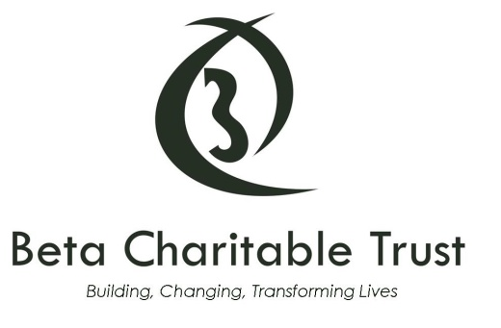

Our Complaints Policy

Beta Charitable Trust is committed to delivering a high standard of service to anyone who engages with our work.

We are keen to hear from anyone who believes we have fallen short of the high standards we set ourselves. You can provide you feedback by phone on +44 (0)1376 507770, email admin@betacharitabletrust.org or, alternatively, you can write to the following address:

Unit 7&8 Swanbridge Industrial Park
Black Croft Way
Witham
Essex
CM8 3YN

We will acknowledge and provide an initial response to your feedback within 10 working days of receiving it. Whilst we expect to be able to resolve most complaints within that timeframe, if we need to conduct a more in-depth investigation, we will aim to provide you with a full response within 20 working days. If we are unable to meet that deadline due to exceptional circumstances, we will of course let you know.

If your complaint is about our fundraising activities and we are unable to resolve it to your satisfaction, you can ask the Fundraising Standards Board, the self regulator for fundraising in the UK, to consider it by:

- submitting your complaint through the FRSB website www.givewithconfidence.org.uk
- writing to Fundraising Standards Board, 65 Brushfield Street, London E1 6AA, or
- calling – 0333 321 8803

Beta Charitable Trust is a member of the Fundraising Standards Board and we agree to abide by its decisions. Please note that the Fundraising Standards Board can only consider complaints received within 3 months of the original incident.

The Fundraising Standards Board will investigate your complaint within 20 working days of receiving it and if you are not satisfied with its conclusions, you can request that their Board of Directors look at it again. Their decision will be made within 60 calendar days, will be final and will be made public.

